|  |
| --- |
|  |
| Code Fair 2017 |
|  |
| Web presence and code fair promotion. |

**Kris BeBbington and Joshua Bauer**

2017

Client: IT Faculty, Charles Darwin University

Code Fair 2017

Web presence and code fair promotion.

Table of Contents

Overview 4

About the project 4

Project Team 4

Business Requirements 5

Project Approach 5

Strategy 6

Business Objectives 6

Competitive Benchmarking 6

User Needs {personas} 7

Concept Map 8

Scope 9

Content requirements (content inventory, sitemap) 9

Technical Requirements 9

Information Architecture 11

Navigation design 11

Page design 11

User Testing 12

Interface & Visual Design 13

Interface Design Features 13

Persistent Header / Top navigation 13

Splash page 13

Buttons 13

Forms 13

Persistent Footer 13

Learn More links / buttons 13

Cross-browser Compatibility and Extensions (JavaScript) 14

Visual Design Inspirations 14

Tapestry Website 14

PureCSS layouts 15

Responsive grid system – purecss 16

Client / User Feedback 16

Navigation 16

Content 16

Experience 16

Site Development 17

Lessons Learned 19

What worked? 19

What didn’t? 19

What would you change if you could do this project again? 20

Conclusion 20

References 21

Appendices 22

Milestone 1: Competitor Benchmarking 22

Milestone 2: User Analysis 22

Milestone 3: Design Description Documents 22

Milestone 4: Usability Tests 22

# Overview

## About the project

The overall goal of this project is to better showcase the CDU Code Fair that has been running for the last 3 years. With current digital trends the best way to achieve this, to not only staff and students, but to the great IT industry is with a website. This goal is to be achieved by providing a platform that promotes the code fair and provides a repository for resources from past events, as well as future events.

The website will be a marketing piece as well as a tool for those wishing to participate. We expect it to be accessible and welcoming to all, but with more of a focus on engaging students as well as professionals from the IT industry.

### Project Team

The project team will consist of two members, Kris Bebbington and Joshua Bauer. The roles on the project will be shared between the two members for the duration of the project. The schedule is below.

|  |  |
| --- | --- |
| **Milestone** | **Co-ordinator** |
| Milestone 1: Competitive Benchmarking | Kris Bebbington |
| Milestone 2: User Analysis | Joshua Bauer |
| Milestone 3: Design Documentation | Kris Bebbington |
| Milestone 4: Usability testing | Joshua Bauer |
| Website development | Kris Bebbington |
| Lead Developer | Kris Bebbington |
| Report | Joshua Bauer |
| Presentation | Kris Bebbington |

### Business Requirements

The faculty have outlined a few business requirements for the website.

Key content the website is communicating is:

-Getting word out for this years competitions

-Providing information to the IT industry

-Past events

Key Function the website is:

-To help motivate and engage students into code

-Provide a platform to advertise to IT industry to get involved

-Provide a repository of information for past and future users

Visitors to the site will remember:

-Easy navigation

-Information available at fingertips

-Accessible no mater what format it’s presented in

## Project Approach

Due to the nature of the project having a it broken down into weeks of released requirements (even though we had an overall high level view) we decided to use a cut down Agile approach to the project. We would meet each Monday evening and work out requirements for the week designed as a mini sprint (The Agile Movement, 2008). We’d then meet again on weekend to put together the information and the coordinator would then submit the week’s work.

This coupled with the use of GitHub and forking each week and tasks section allowed us to work separately yet in the same direction and collaboratively. With the weekend we would then pull the fork back into the master and start the next milestone.

Outside of the actual project management approach, we also took a mobile first or responsive web design approach. This was not only laid out by the project scope but is a good way to develop a site, noting, “A web page should look good, and be easy to use, regardless of the device!” (HTML Responsive Web Design, 2017)

# Strategy

To determine how to position the website to best meet the business requirements of the client, a number of activities were undertaken. This included understanding the business objectives in some depth through competitor benchmarking; a user needs analysis with personas and scenarios developed and the development of a concept map or model.

## Business Objectives

### Competitive Benchmarking

As part of the development process for designing the CDU’s 2017 Code Fair site, we performed competitive analyses of 2 similar websites.

Competitor 1 - https://www.cyberchallenge.com.au

Competitor 2 - http://www.eng.unimelb.edu.au/engage/schools/codemasters

Our criteria for choosing these websites was based on the following themes:

- Code Fair

- Code Masters

- Coding Competition

- University Coding

We focused on information inventory, functionality inventory, visual layout and general user experience. Main observations focused on User Experience, Usability, Responsive Design and Accessibility.

Strengths

* Responsive Design
* Unobtrusive JavaScript
* Encryption / privacy
* Availability of content from past events
* Page load time
* Valid / semantically correct coding
* Accessibility
* Information well-laid out, easily findable, hard to get lost

Weaknesses

* Navigation – missing back / top buttons, lacking hovering navigation
* JavaScript links broken when disabled
* Fails contrast test
* Incorrect form usage
* Content incorrectly labeled, or not obvious to user

Although we discovered that the sites were overall valid and accessible and were responsive, it really was the little things, that made the sites not as “user friendly” as they could have been, for example just missing a “Back to top” button on long pages.

## User Needs {personas}

The main user groups most likely to use the website are college or high school students and representatives form the IT industry (Appendix 2). This isn’t only the target audience but who we believe will have a need and a want to visit the website.

What we want to achieve for the website is not only to get students to sign up, which is a main focus of the site, we also want it to be as accessible to other users. Having said that, we also want to make sure we incorporate the little things and make it easier to get around the site.

We learnt a few things from working with our wireframe and running our first simple usability test with the wireframe. Most of these changes were to do with the placement of content and adjusting the number of navigation links per page.

With the full user testing (Appendix 4) we have learnt a lot more and focusing on accessing the required information the user requires in as little effort as possible, this includes both the IT representative and the students.

### Concept Map

Using the idea that we want to promote this year’s event as well as get industry involved (and not forgetting a repository of old events), we designed the concept map below.

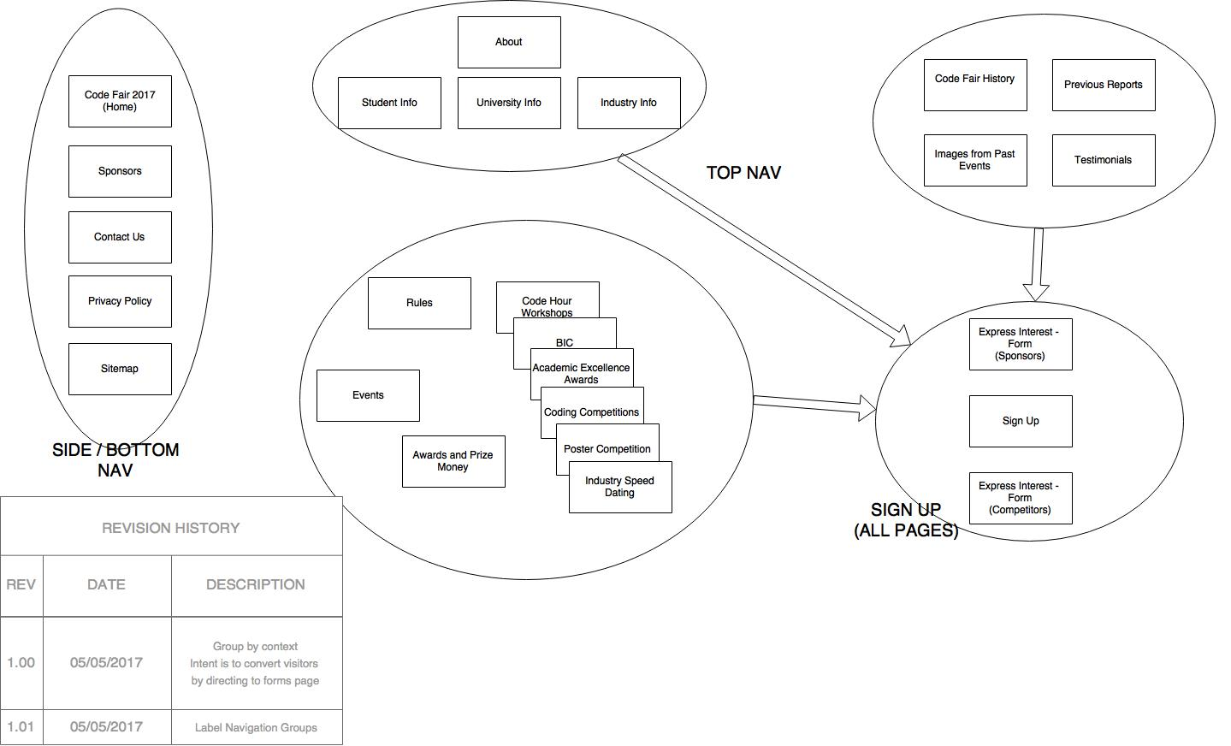

The main concept was to get students involved and IT involved, so our main focus was having signup link form all pages and have it visible. Second to this we wanted access to “more information” and last years events, this is also how all the content fell into each group easily. The above map changed slightly towards the end after user testing but the main idea is still the same.

# Scope

Knowing the content and understanding how it fits into the website is important, if you have too much information people can get overwhelmed and not having enough the opposite. What is also true is if you have the wrong information. Developing a website around architecture but the content is based on coding will not give the required result.

### Content requirements (content inventory, sitemap)

We reviewed the content supplied by the faculty and noted there are a few groupings of information. We developed with concept mapping and after running through a few sitemap changes, but we feel the information when put into these groups allowed for the containment of information. This logical layout allowed for easy placement of data and content and also allowed for users to easily find information.

Note in the sitemap (Appendix 3) that we grouped into targeted info, event info, history and signup. Since developing the wireframe and with user testing we adjusted this, but still have basic groups of content.

### Technical Requirements

We have opted for a minimal approach to JavaScript and really tried to use it sparingly. However we’ve used JavaScript to try and enhance or make easier the use of the website. The three main areas we have used JavaScript in is:

* Form validation
* Modal display for snippets of information
* Photo gallery

The previous mentioned areas were designed first with HTML and CSS only and with mobile devices and other media in the front of our minds (this aside from form validation which without JavaScript will validate on server side). Once confirmation of only HTML and CSS was working we were then able to pursue JavaScript to help enrich the use of the website.

We started with the Form Validation; we did not want to recreate the wheel though considering it’s been done so many times before. We settled on jQuery Form Validator (jQuery Form Validator, n.d.), mainly based on the usability and simple design and it’s integration with HTML5 validation. The form is more of an email off to staff and as such didn’t need very strict validation, however we wanted to make sure that people who have legitimate sign ups or requests gave the right information. The jQuery is run by setting events listeners to “data-validation” attribute in the “input” DOM element. This allows rapid deployment and can run over many forms in a single page. We only needed validation for having something in the name field, and properly formatted email and a phone number field with numbers in it.

The second area we focused on was modal display for the privacy policy. This is a very simple piece of JavaScript, however we believe rather important to be able to have more information in a website than you actually need to display in any one time, ie only showing when a user want’s to see it. We started with a normal link to a page that opens in a new tab to show the privacy policy just in case of JavaScript issues with client rendering. All we had to do then was create a DIV in HTML, set it to hidden in CSS and attach an event listener in JavaScript to set it back to display block.

The last area was the Photo Gallery, create this from scratch just would not have been feasible in the timeline we had, so again we went looking for a 3rd party alternative. We turned again to jQuery and found a powerful product called PhotoSwipe (Semenov, 2017). This was exactly what we were looking for, having a gallery of thumbnail images already present and displaying then in a image gallery with failover to hard links to the full size images. PhotoSwipe did have a lot of setup and configuration though to get started. This didn’t just mean the import of the js files, but also had a set of CSS files and still needed to create the image gallery in the right format for the DOM to get parsed by the jQuery plugin. There are some powerful features in this plugin, but we went with a simple set of images with links already present and used the jQuery to find the images and create a list and then inject that in the plugin (the image gallery itself). The result is really something and looks great and also fails over with the end user not knowing any different.

With all the steps above noted we took a mobile first approach testing at each part on mobile and then working out kinks and “extra bits” on a computer. We also took this with naming and labeling and sematic layout of HTML to allow for non-web devices to be able to represent the data/information for those not even using a browser. This is tested in steps of disabling options in the browser, first JavaScript, second CSS and then using a text only browser. The site still gets across the required information albeit not as pretty but in a satisfactory fashion.

# Information Architecture

Information architecture, as the same suggests, is the design identification and definition of site content and functionally. This also entails the structure and defines the relationship between the sites content and functionality. You don’t see the information architecture from the end product however it the basis for the decisions made to represent the UI. This information architecture is developed from content inventory, audits, information groupings and metadata. (Cardello, 2014)

### Navigation design

The navigation for the site was designed around a set of “what we won’t be doing” notes, mostly from personal experience and noting from Steve Krug. Krug’s idea of “don’t make me think” is a great starting point for website development and more specifically navigation. We noted our own personal bugbears when it came to websites and most common were, multi layer menus, or drop down or drop across menus and having menus all over the page.

Our design for navigation was simple; let’s keep it simple. Using the concept map and then having the site map note that the information for most things is in a category understood by everyone we went with a simple 4-item menu. Code Fair 2017, Past Events, Learn More and Sign Up. This aligned with the content for the site and aligned with the goal of presenting to, students to sign up, promoting current and past events to the greater community and encouraging participation of the IT industry at large.

### Page design

We wanted to focus on keeping the information and content on the site in bite size pieces to not overwhelm users and making it easy to follow pages and information throughout the site. We first decided on a single page site with sections for each navigation item. It quickly became apparent that this (although design properly with back to top links and other features) was not really easy to follow and would make the navigation hard to implement.

We still wanted to use the single page idea to try to minimize clicks throughout the site, so we settled on a hybrid method. Using the concept mapping we selected the information for each separate page and filtered out small important bits to establish each section. We decided to keep the most important or we believed most visited data on top. Each heading of each section is large and in contrast to the section before. The information in each section is to the point and also in contrast to not only the background but also other text above and below.

We tried to incorporate a Z-pattern hierarchy because of the low volume of information and text-lite pages. (Soegaard, 2017)

### User Testing

We tested a couple of scenarios from the point of view of an industry representative and a university student. The focus on these two types of users was mainly based on the fact that they are the two groups we are focusing the website on, and the people to get the most out of the website.

The tests themselves (Appendix 4) focused on the user needing to gather more information or signing up for the Code Fair, this is what we perceived to be the main requirements for both users. The scenario for the industry representative was “You are an industry representative and want to find out how to get involved in the code fair in any capacity.” As for the student the scenario was “You are a university student, you are looking at ways to present your ideas/abilities to the industry and come across the code fair at CDU, if you confirm there is a way you can do this you then sign up.”

We noticed a few things when testing with the users, but the main problem we noticed was that users, when looking for information, went straight to the navigation first and didn’t even scroll down the first page to see if what they needed was there. Then once they “select” a menu item, the page it lands on they then scan the page for the information they require. We ended up using this information in our final design and adjusted navigation items (based on the concept map) to only have the 4 navigation items we ended up with, one being “Learn More”, which in our testing was the main item people went to first. So we ended up putting more information in Learn More that linked back to the first page or other pages on the site.

# Interface & Visual Design

## Interface Design Features

The following interface design features were used as part of the visual design of our site for the Code Fair:

### Persistent Header / Top navigation

We attempted to keep the page count minimal, so the top navigation contains only a few links.

We decided against a dropdown menu within the top navigation, the nature of the site encourages visitors to scroll through each page, without the need for the clutter of extra intra-page navigation in links. The “Learn More” buttons provide a more targeted pathway for visitors who are interested.

### Splash page

We liked the idea of having a splash page with the code fair logo and the sign-up button as an introduction to the site. A persistent image / theme that is overlaid as the user scrolls down the page gives the appearance and feel of separation of content and visual themes.

### Buttons

We chose to use buttons for the “Learn More” links within the main page to attract the user to engage further in the content.

### Forms

Keeping the form layout simple, we hoped to encourage visitors to submit an entry into the code fair.

### Persistent Footer

A persistent footer for easy navigation to “other” content, such as the site’s Privacy Policy, Site Map and Contact Us.

### Learn More links / buttons

We decided to keep the home page as simple as possible, with only brief descriptions of the Code Fair’s events. Adding “Learn More” buttons which navigate to another page with more detailed descriptions of events, allowed us to convey the information to visitors with a genuine interest, while keeping the home page brief.

Usability testing revealed the need to add easily discoverable links for more information.

### Cross-browser Compatibility and Extensions (JavaScript)

Our initial approach was to use a feature rich front-end development tool like Bootstrap.

We realized this was going to limit our site’s functionality on older browsers, our “vertical one-page scroll” would be JavaScript heavy, and be a different site altogether with JavaScript disabled.

PureCSS (Yahoo!) was just one styling tool we looked at that performs well using CSS alone, and allowed for easy JavaScript add-ons. It also is designed for use on older versions of Internet Explorer.

## Visual Design Inspirations

### Tapestry Website

<http://tapestry.life/welcome#HOME>

This website impressed us in terms of user experience. It was the first layout we considered when conceiving our wireframes. It relies heavily on the use of JavaScript however, and for our purposes would compromise user experience for users on non-JavaScript-enabled browsers.



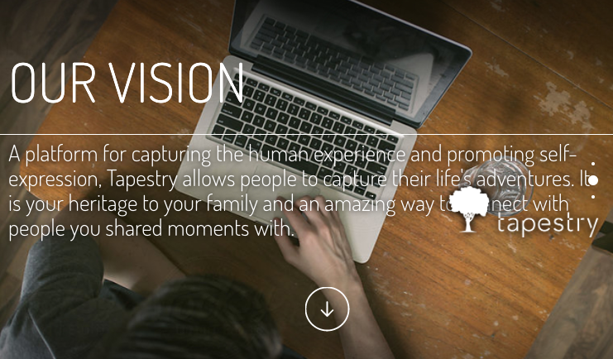Users can scroll down or click the down arrow to see the next “page”.

Three pages in total, the site displays just enough information to engage the user along with the animated “feel” of dropping to the next page.

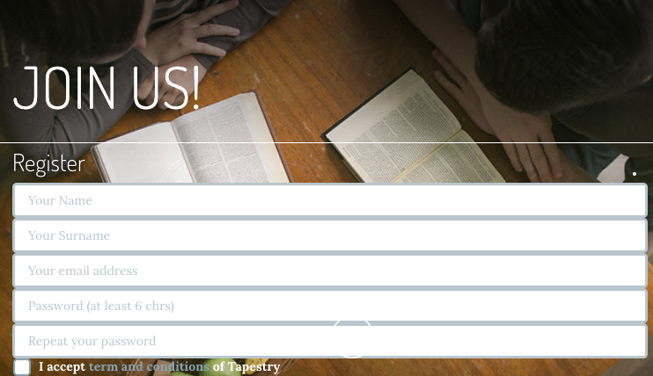

Having a full page dedicated to the Join Us form inspired the idea for the Sign-Up form on our site. While the “one-viewport-per-page scroll” feature was not included in our site, the idea remained with the placement of our form with full screen size on all pages.

### PureCSS layouts

<https://purecss.io/layouts/marketing/>

This was the foundation for our Code Fair site. It aligned with our idea to have a one-viewport per page scrolling feature, but did not require JavaScript.

PureCSS is also a minimal package, so page loading speed would not be a factor when loading stylesheets or scripts.

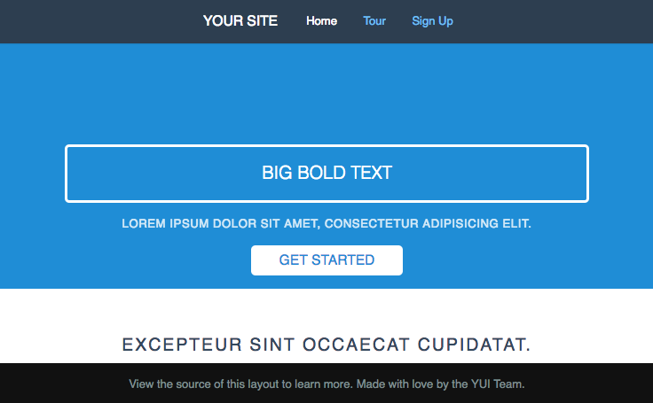

### Responsive grid system – purecss

PureCSS (Yahoo) contains a grid system which proved useful for the purposes of displaying our layout.

PureCSS also includes styling for responsive images, which simplified the task of cross device coding.

All that is required is the addition of a “pure-responsive-img” class to our photos and images, and PureCSS ensures the sizing remains responsive across devices.

## Client / User Feedback

### Navigation

As content has been progressively added, the main focus of user testing was on the site’s navigation. The overall navigation prototype was mostly functional; we anticipated the need to reduce content and to not have an excessive number of pages to browse through. Suggestions were made to add links to further information about coding events.

### Content

Suggestions and feedback we received for content focused on event information, and the sign-up form. We needed to make these both easily discoverable. The sign-up form had to be accessible from anywhere on the website. Testing showed users would access the form via scrolling, clicking a button, or using the top navigation link. The form had to be simple enough to not deter the user from filling it out. Content needed to be browsed easily. This meant concise headings and information. Our testers tended to click through links, “just to look”.

### Experience

User experience feedback was positive during the prototype testing. Generally, users said the site “looked good”, and commented that it worked well on their mobile phones. Site navigation was achieved with relative ease; early testing demonstrated the need to compress our layout within 2-3 pages to maintain user’s attention.

# Site Development

The following table represents aspects of the project and tasks performed by each team member.

|  |  |  |
| --- | --- | --- |
| Milestone 1  Week 7 | Coordinator: Review and submit Milestone 1 | Kris Bebbington |
|  | Team Roles / Decide Project | Kris Bebbington  Joshua Bauer |
|  | Competitive Analysis | Kris Bebbington  Joshua Bauer |
| Milestone 2  Week 8 | Coordinator: Review and submit Milestone 2 | Joshua Bauer |
|  | Content Inventory | Kris Bebbington |
|  | User personas and scenarios | Kris Bebbington  Joshua Bauer |
| Milestone 3  Week 9 | Coordinator: Review and submit Milestone 3 | Kris Bebbington |
|  | Site Map | Kris Bebbington |
|  | Navigation prototypes  Paper  HTML Wireframe | Kris Bebbington  Joshua Bauer |
|  | Usability Test (design)  Usability Test (perform) | Kris Bebbington  Joshua Bauer |
| Milestone 4  Week 10 | Coordinator: Review and submit Milestone 4 | Josh Bauer |
|  | Prototype User Testing | Kris Bebbington  Joshua Bauer |
|  | Share wireframe | Kris Bebbington  Joshua Bauer |
| Coding | Coordinator | Kris Bebbington |
| CSS | CSS layout / coding  CSS coding / proofing | Kris Bebbington  Joshua Bauer |
| HTML | HTML content / coding  HTML Wireframe / coding / proofing | Kris Bebbington  Joshua Bauer |
| JavaScript | JavaScript Photo Gallery  JavaScript Form validation  JavaScript Privacy Policy modal  JavaScript proofing | Joshua Bauer  Joshua Bauer  Joshua Bauer  Joshua Bauer |
| Report | Coordinator | Joshua Bauer |
|  | Interface and Visual Design  Site Development  Lessons Learned  Appendices | Kris Bebbington |
|  | Overview  Strategy  Scope  Information Architecture  Conclusion  References  Appendices | Joshua Bauer |
| Presentation |  | Kris Bebbington  Joshua Bauer |

# Lessons Learned

## What worked?

* Communication
  + Josh and I found communicating with each other easy. We used email, GitHub, and Skype to give each other updates, or outline tasks for the coming week.
  + Fortunately, we both agreed on the direction we wanted to take with the site early on, so putting the ideas to paper was a relatively simple process.
* Team roles – played to strengths
  + Initially, tasks were assigned to make a balanced workload for both of us. Josh suggested he wanted to do the JavaScript part of the project, and I knew I would get a lot of out the CSS and layout part of the design process, so our individual focus aligned with the team roles delegated. While CSS / layouts are not exactly “my strength” it was good experience to concentrate on the overall user experience of the site.
* Wireframe / prototype process
  + Draw.io was perfect for our paper wireframes. Both of us being external students, and having to communicate electronically, paper layouts were going to be a nuisance.
  + Using the draw.io website along with GitHub, we were able to maintain a version control and sharing of ideas easily. I could draw a basic paper prototype and Josh could convert it to HTML and we could both be updated on progress via GitHub’s notifications. This process seemed to work well for us.
* User tests
  + User tests provided valuable feedback in terms of site content and navigation.
  + Testing demonstrated the need for us to:
  + Add links for more information in the Coding Event section
  + Reduce lengthy content on the home page, and splash screens on other pages
  + Hold user focus by giving concise information and a simplified and easily discoverable form to assist in our response rate

## What didn’t?

* Time coordination
  + Time coordination was a minor issue - other members’ work (Josh) at times was stalled waiting for someone (me) to complete a task. This was a problem I was most guilty of causing, often preferring to complete tasks closer to the end of week, after absorbing the week’s material.
* Excessive content
  + We would have benefited from interviewing our key stakeholders to narrow down the scope of information required on the website. Content was derived mainly from past reports, and sites for previous Code Fairs. We tried to keep the goal of user participation paramount, as we believed this was clearly indicated in the report’s goals.

## What would you change if you could do this project again?

* Begin the coding process earlier in the development cycle
* Determine necessary content from site stakeholders earlier in the development cycle
* Manage tasks more efficiently – in the above case for time coordination, I think setting more independent tasks would have minimized the impact of different timings. For this project, however, tasks were often overlapping due to us only having 2 team members. For assessment purposes, we took turns as coordinator and tried to balance the workload. In future, I would structure the team roles based on priorities such as working independently, and continuity / nature of tasks. I would also prefer to utilize an independent coordinator overseeing the entire project, as opposed to “taking turns” coordinating, or coding, or testing. A larger team would be required.

# Conclusion

Designing a site to educate the wider community, get students involved in coding and make the IT industry get involved at face value appears easy. However, when you really get down to the nuts and bolts making sure you’re not making mistakes not teach students the correct standards and not look foolish in front of industry is no small feat.

Using a mobile first responsive design that also incorporates progressive enhancement, the site was designed around being inclusive and accessible. Even to the point of removing word and pdf documents and using that information in HTML (as both are not considered accessible by web standards).

We have learnt a lot of lessons from this process as well. This is not only regarding coding but also process and procedure and even design aspects that will be taken into the next and subsequent projects.

We believe we have delivered not only the students can be proud of, but also a site industry can stand by even use as an example to their friends and associates. Considering the short timeline and worked required the objects and scope has been achieved.

# References

Anon, 2008. *The Agile Movement*. [online] Agile Methodology. Available at: <http://agilemethodology.org> [Accessed 23 Apr. 2017].

Anon, 2017. *HTML Responsive Web Design*. [online] W3 Schools. Available at: <https://www.w3schools.com/html/html_responsive.asp> [Accessed 6 May 2017].

Anon, n.d. *jQuery Form Validator*. [online] jQuery Form Validator. Available at: <http://www.formvalidator.net> [Accessed 12 May 2017].

Cardello, J., 2014. *The Difference Between Information Architecture (IA) and Navigation*. [online] Nngroup. Available at: <https://www.nngroup.com/articles/ia-vs-navigation/> [Accessed 16 May 2017].

Semenov, D., 2017. *PhotoSwipe: Responsive JavaScript Image Gallery*. [online] Photoswipe.com. Available at: <http://photoswipe.com> [Accessed 9 May 2017].

Soegaard, M., 2017. *Visual Hierarchy: Organizing content to follow natural eye movement patterns*. [online] The Interaction Design Foundation. Available at: <https://www.interaction-design.org/literature/article/visual-hierarchy-organizing-content-to-follow-natural-eye-movement-patterns> [Accessed 14 May 2017].

# Appendices

## Milestone 1: Competitor Benchmarking

* 1. Cyber Challenge, https://www.cyberchallenge.com.au, Joshua Bauer
  2. Code Masters, http://www.eng.unimelb.edu.au/engage/schools/codemasters, Kris Bebbington

## Milestone 2: User Analysis

Use the template provided in Learnline (Week 8 Tasks).

1. Persona & scenario: Chris, Joshua Bauer
2. Persona & scenario: Phil, Kris Bebbington

## Milestone 3: Design Description Documents

1. content inventory - Josh and Kris
2. concept model - Kris
3. site map - Kris
4. navigation prototypes - Joshua and Kris
5. page description prototypes - Joshua and Kris

## Milestone 4: Usability Tests

* User Test 1: Joshua Bauer
* User Test 2: Kris Bebbington

Appendix 1 Competitor Benchmarking

Author: Joshua Bauer

Competitor 1: Cyber Challenge (https://www.cyberchallenge.com.au)

## Screenshots

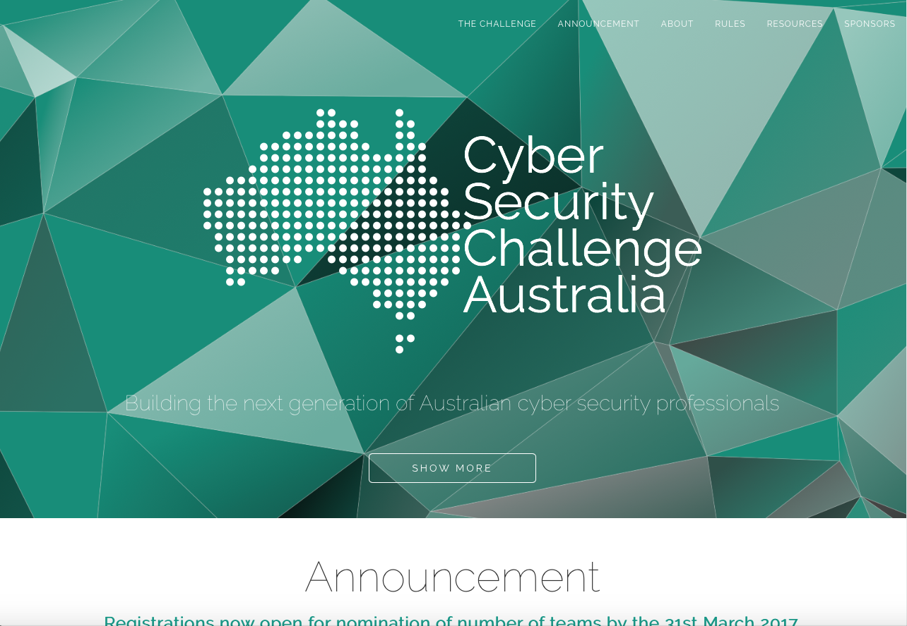

Cyber Challenge Home Page

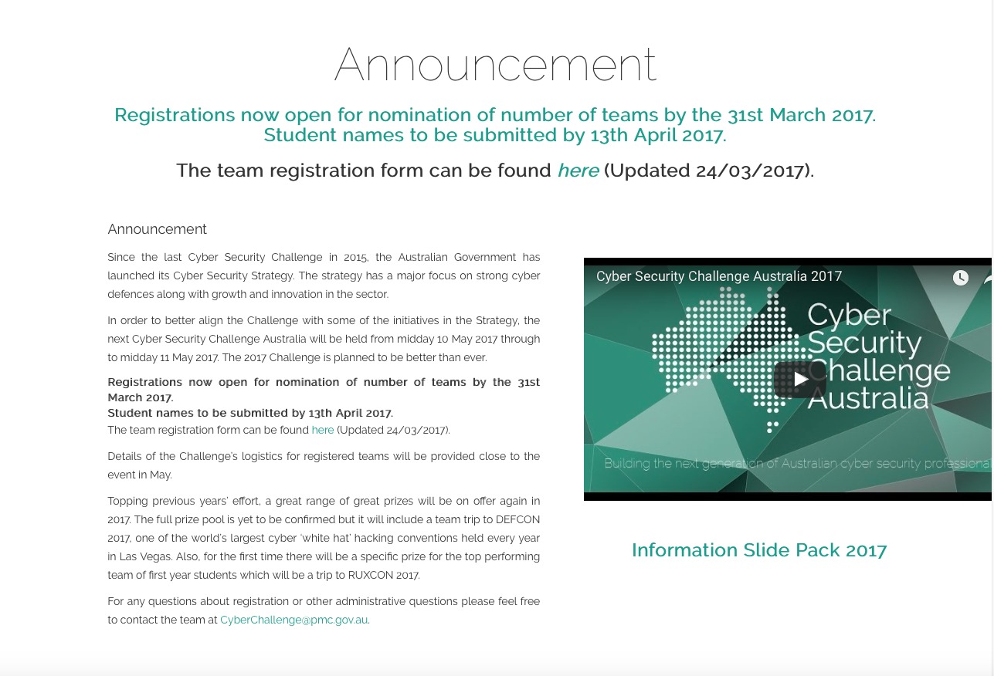

Cyber Challenge Sub Section (Page)

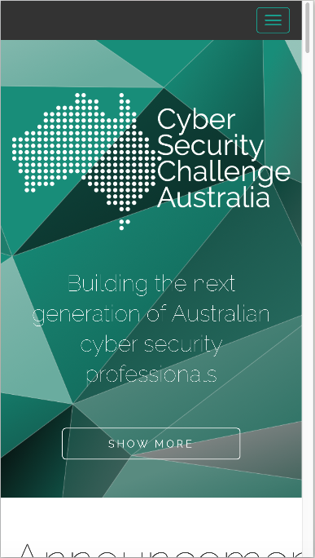

Cyber Challenge Mobile View (iPhone 6s)

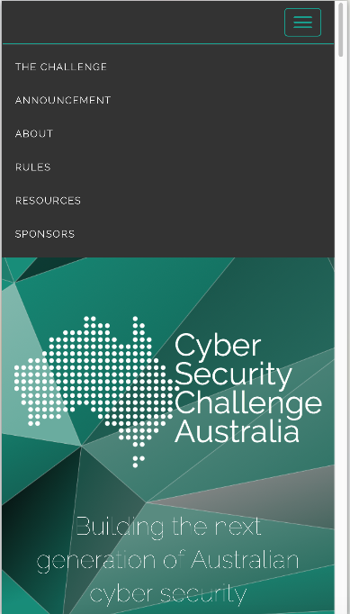

Cyber Challenge Mobile View with menu (iPhone 6s)

## Content/Functionality

Cyber Security Challenge Australia is a single page flyer site for the advertising of a hacking challenge presented by the government. The overall design is simple and appears to have all information available simply.

Specific content/function is listed in terms of analysis:

#### Information Offered:

* “Poster” home page
* Announcement – overall details and where to get extra information
  + Video
  + Registration form
* The Challenge – What the challenge entails and how it came about
* Rules and eligibility
* Terms and Conditions
* Privacy Statement
* Resources
  + Past results
  + Solutions
  + Prizes
* Sponsors
  + Links to sponsors

#### Technology Used:

* HTML5 and CSS3
* Bootstrap
* JQuery for animation and DOM manipulation
* Google Fonts
* Cookies for tracking (used with analytics)
* Google Analytics
* YouTube video
* Local storage and session storage for YouTube embedded video
* Word and PDF forms
* Email addresses in page

#### Search Functionality:

* None

## Strengths

The greatest strength of this site is the well laid out information, easily findable and hard to get lost.

#### Specific strengths include:

* Responsive, mobile first design
* Main content and links work without JavaScript
* Minimal, useful images/graphics
* Page loads very quickly
* Links descriptive
* Each section or “page” is well defined
* Resources and solutions available from previous events
* Uses SSL for encrypted data
* Semantic correct code
* When styles disabled page displays information in order and easily readable

## Areas for Improvement:

The main issue found with the site was that there is no easy movement between “pages” or parts of the page, missing some sort of back button or top button or having a hovering navigation.

#### Specific areas for improvement:

* Floating navigation or top of page links from each section
* 2 policy links and past events are JavaScript only and break when disabled
* When styles disabled logos for sponsors are far too large and break page flow
* Contrast ratio of 3.34:1 on most text, fails AA and AAA test for normal text
* Missing first level heading (h1)
* Email addresses used instead of forms
* Links to documents are extraneous “click here”, “here”
* A few links and images missing Alt text
* Use of justified text, makes hard for reading flowing text
* Word documents are used; documents have limitations in accessibility
* PDF documents are used, often have issues with accessibility and need third party application
* Cannot tab through links (keyboard use)

Author: Kris Bebbington

Competitor 2: Code Masters http://www.eng.unimelb.edu.au/engage/schools/codemasters

## Screenshots

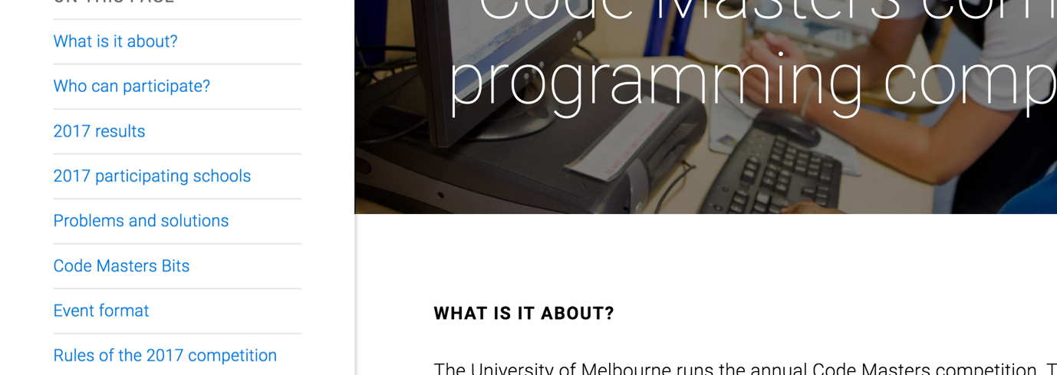

Screenshot Home Page

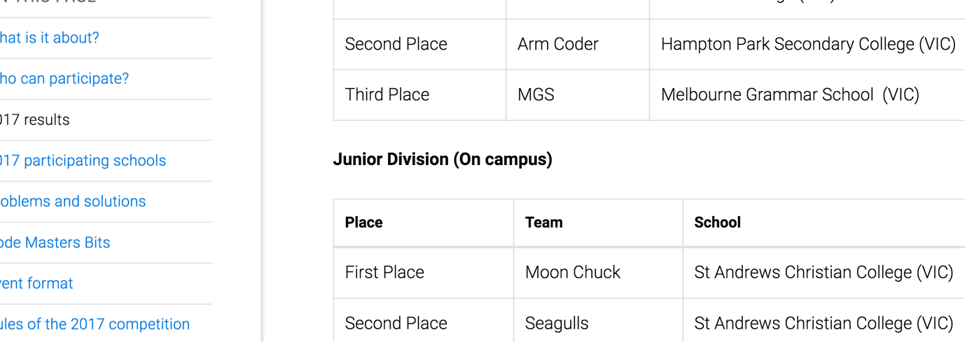

Screenshot Home Page

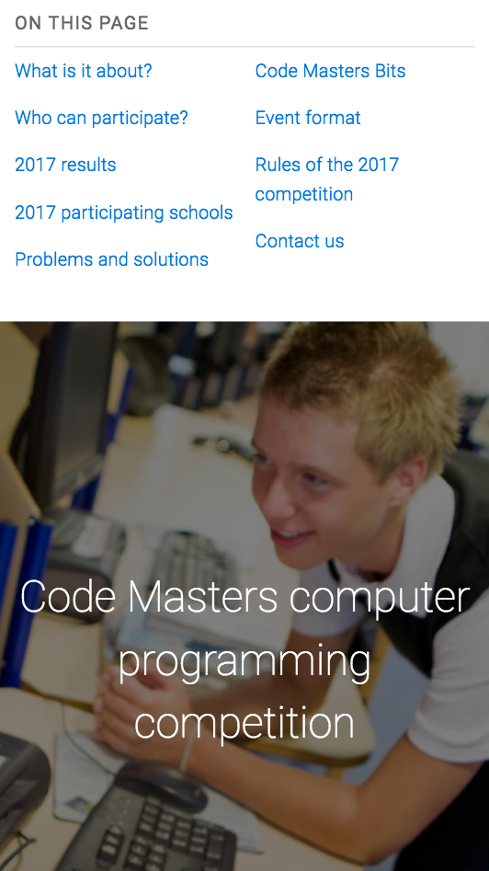

Screenshot IPhone 6 Portrait

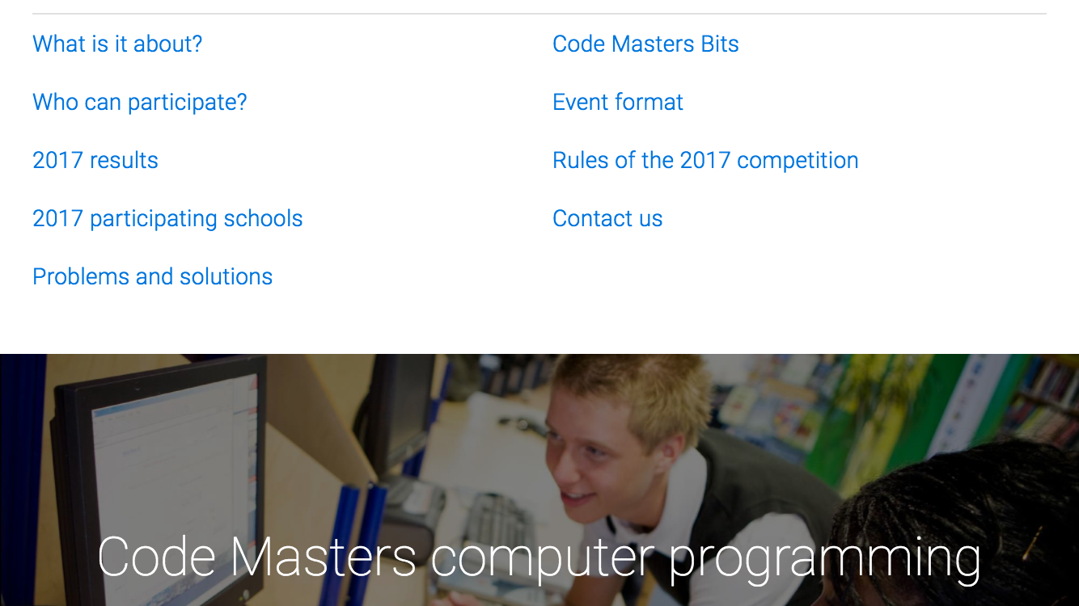

Screenshot IPhone 6 Landscape

## Content/Functionality

The Code Masters website promotes the annual programming competition run by the School of Engineering at the University of Melbourne. It features all information for the competition on a single page, and has an easy to use in-site navigation menu, and search facilities.

Content and functionality specifics:

#### Information Offered:

* What is it about?
* Who can participate?
* 2017 Results
* 2017 Participating Schools
* Problems and solutions
  + Code Masters website – previous winners, leadership boards (lengthy) and problems / solutions. Registration. User management.
* Code Masters Bits
  + Code Masters Bits website - Currently run, all-year round competition with questions and leaderboard, rules. Team Registration.
* Event format
* Rules of the 2017 Competition
* Contact us

#### Technology Used:

* HTML5 and CSS3.
* Google Fonts.
* University of Melbourne styling (shared stylesheets).
* University of Melbourne shared JavaScript (common user functionality).
* Google Analytics.
* Isotope JavaScript layout.

#### Search Functionality:

* Easily seen. Prominently displayed upper right hand side of page.
* Available with JavaScript Enabled only.

## Strengths and Weaknesses

* Markup (HTML5)
  + Well written and easily understandable HTML5 markup.
  + Validation – passed.
* JavaScript / CSS
  + “No-JavaScript” fallback – designed for use without JavaScript functionality.
  + Polyfills – IE < v9.
  + With JavaScript off
    - Menu functionality moved (top right).
    - Layout at bottom of page stacked – not impressive visually.
    - Simplified Navigation Bar – List contains no styling and looks primitive.
    - Main content remains accessible.
    - Search functionality removed.
  + Uses University of Melbourne JavaScript files and stylesheets.
    - Minimized CSS– difficult to analyse.
* Accessibility
  + Passes Chrome accessibility audit for most content.
    - Missing alternative text for some content.
  + Passes contrast testing 21:1 AAA.
* In-site navigation
  + Focused sidebar – focus adapts as page scrolls.
* Content
  + Similar requirements to ours.
  + Useful information.
  + Past events and results included.
* Top navigation
  + Inter-organizational navigation (Links for University of Melbourne).
  + Dropdown menu top right is visible and easy to find.
  + Search functionality top right is visible and easy to find.
* Responsive Design
  + Designed for mobile first.
  + Layout changes between device sizes.
  + Side menu moves to top as screen get smaller.
  + Some scrolling still required when side menu still on side.
  + Overall responsive site. Works well across devices
* Visual styles
  + Images / multimedia.
  + Easy to find search – done.
  + University Sitemap at bottom of page.
  + Performs well with styles removed.

## Strengths

* Mobile first, responsive design.
* Accessibility.
* Simplified markup.
* Style themes consistent with rest of organization.
* In-site location and navigation.
* Search functionality highly visible.
* Sitemap for organisation.

## Areas for Improvement:

* Site is insecure
  + No use of SSL for encryption.
* Accessibility
  + alt text required for all images
* Previous Events and Results– Not highlighted in a menu.
  + Labelled as Problems and Solutions, and positioned within the page content.
  + Could be labelled more appropriately and accessible via side navigation.
* Unobtrusive JavaScript
  + Provide Search functionality when JavaScript disabled.
  + Apply styling to top navigation links when JavaScript disabled.

Appendix 2 user ANALYSIS



Chris  
Year 12 Student

**Personal Profile**

**Chris is finishing year 12 and is unsure what to do after high school, let alone what University to attend.**

**He has a love for robotics and making things to make his life easier, this includes working with PowerShell in windows to help automate daily tasks. He feels this is a path he could be happy with and is constantly reviewing what his career may be.**

**What Chris wants to find is a site that gets him excited and involved in doing what he loves. He wants to also find out what company's he should be watching or wanting to get employed by. Mostly though he wants to compare himself with people who he feels are “still his age”.**

**Personal Information**

**Profession:** Student

**Location:** Darwin, NT

**Age:** 17

**Hobbies:** Gaming, surfing the net, robotics

**Favorite TV Show:** The Walking Dead

**Personality:** Shy, friendly, inquisitive.

**Internet usage**

**Internet experience:** Advanced (Online before School)

**Primary Uses:** Gaming, chat, videos, email

**Favourite Sites:** Facebook, YouTube, IGN

**Hours online per week:** 25-30

**Computer:** Alienware, ADSL2, Chrome

**Study information**

**Current qualifications:** Year 11

**Literacy:** High Level

**IT Skills/knowledge:** Very High, able to manipulate OS, basic Linux knowledge, understanding of code.

*“Seeing code come to life is amazing”*

* Looking for a challenge
* Love for coding and figuring out problems
* Unsure what to do after high school

**User Goals**

Chris comes to the site to…

* Learn more about what others are doing
* Find pathways for what to do after year 12
* See what level he needs to be at
* Find ideas for making things himself
* Discover companies in the industry

**Business Objectives**

We want Chris to…

* Visit the site often
* Be excited about coding
* Be excited about his future
* Feel CDU will give him that future
* Want to sign up while at CDU
* Recommend the site to friends
* Review past entries

# Chris Scenario

Chris does a Google search for “Darwin code”, follows a link to the sites home page. He discovers this is a code fair put on by the local university. He follows a link to confirm if he is eligible to enter. He confirms he is not allowed to enter, but also states he can look at past events and challenges.

Chris follows links to past events. From there he reviews the photo gallery to see what people physically made and the people involved. He then wants to learn more about the challenges and follows the link to past challenges. He runs out of time and bookmarks the page.

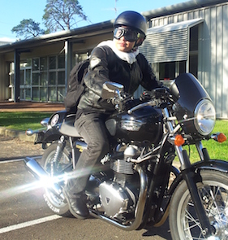

**Business Objectives**

We want Chris to…

* Visit the site often
* Be excited about the competition
* Feel encouraged about finding job
* opportunities
* Recommend the site to friends
* Review past entries

**User Goals**

Patrick comes to the site to…

* Register interest in the coding competition
* Make connections with potential employers in the IT industry
* Test his skills against other people in his field

*“Live life to the fullest”*

* High achiever
* Experienced coder
* Looking for job opportunities in IT

**Personal Information**

**Profession:** TertiaryStudent (IT)

**Location:** Darwin, NT

**Age:** 23

**Hobbies:** Indoor soccer, coding, blogging.

**Favorite TV Show:** Homeland

**Personality:** Extroverted, enjoys meeting new people.

**Internet usage**

**Internet experience:** Advanced

**Primary Uses:** Studies, coding, email, blogging.

**Favourite Sites:** Reddit, Google, WordPress

**Hours online per week:** 40+

**Computer:** Macbook Pro, ADSL2, Safari

**Study information**

**Current qualifications:** Year 12,

**Literacy:** High Level

**IT Skills/knowledge:** Advanced,

2nd year University IT, network administration, coding, database design.

**Personal Profile**

**Patrick is attending Charles Darwin University (CDU) as an IT Student. He is hoping to find work as a software developer when he finishes his degree. He enjoys playing sports, and socialising with friends.**

**Patrick has heard about a coding competition held by CDU, and wants to register his interest. One of his classmates was offered employment at a previous code fair, and Patrick was hoping to find similar opportunities for himself.**

Patrick  
University Student (IT)

# Patrick Scenario

Patrick has heard about the website from his lecturers and other students at Charles Darwin University.

Patrick follows a link from his course note announcements and wants to know more about the prize money for the Coding Fair. He notes there are other events of interest to him, namely the *Industry Employer Speed Dating* event.

Patrick decides he wants to register for the Code Fair, and finds this process intuitive and efficient. Patrick talks about it with his classmates and they think about visiting the site also.

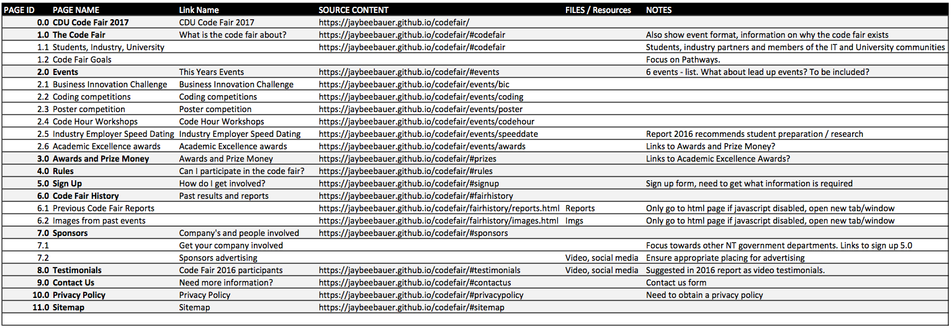Appendix 3 Design Description Documents

Table 1 – Content Inventory

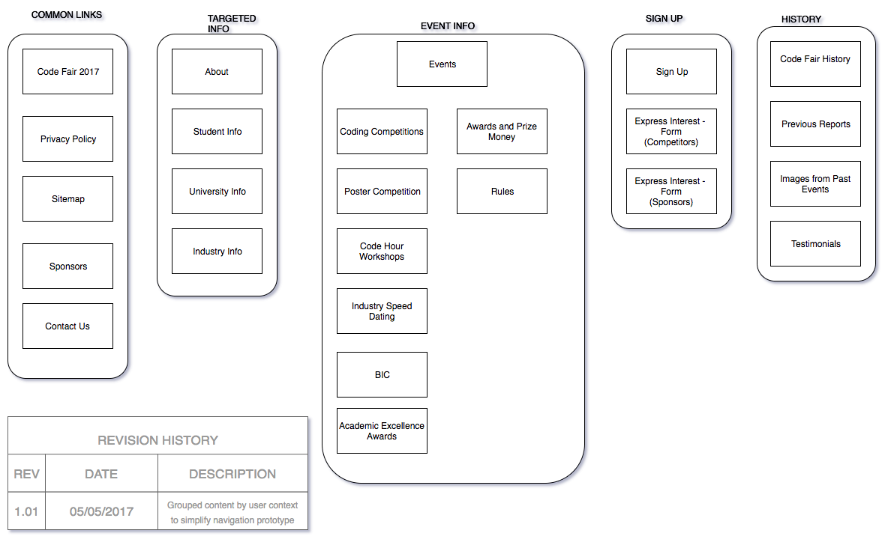Figure 1 – Site Map

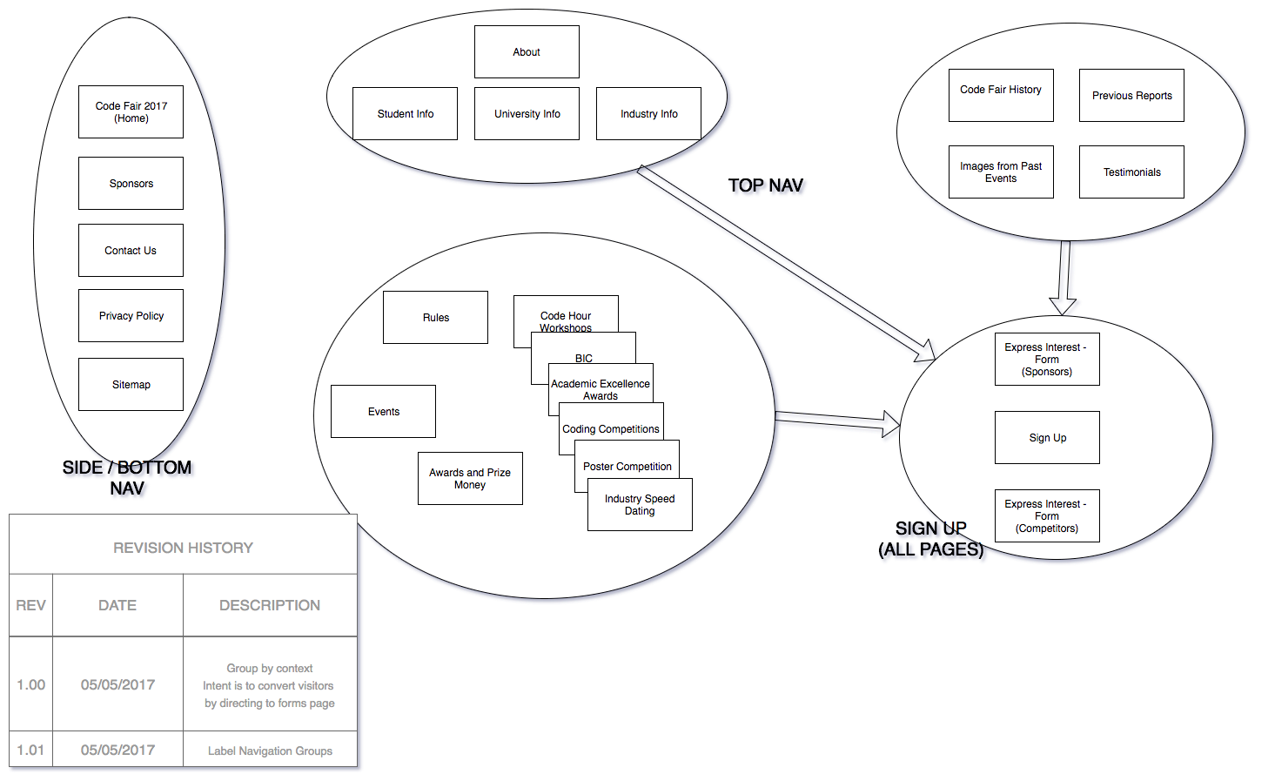Figure 2 – Concept Map

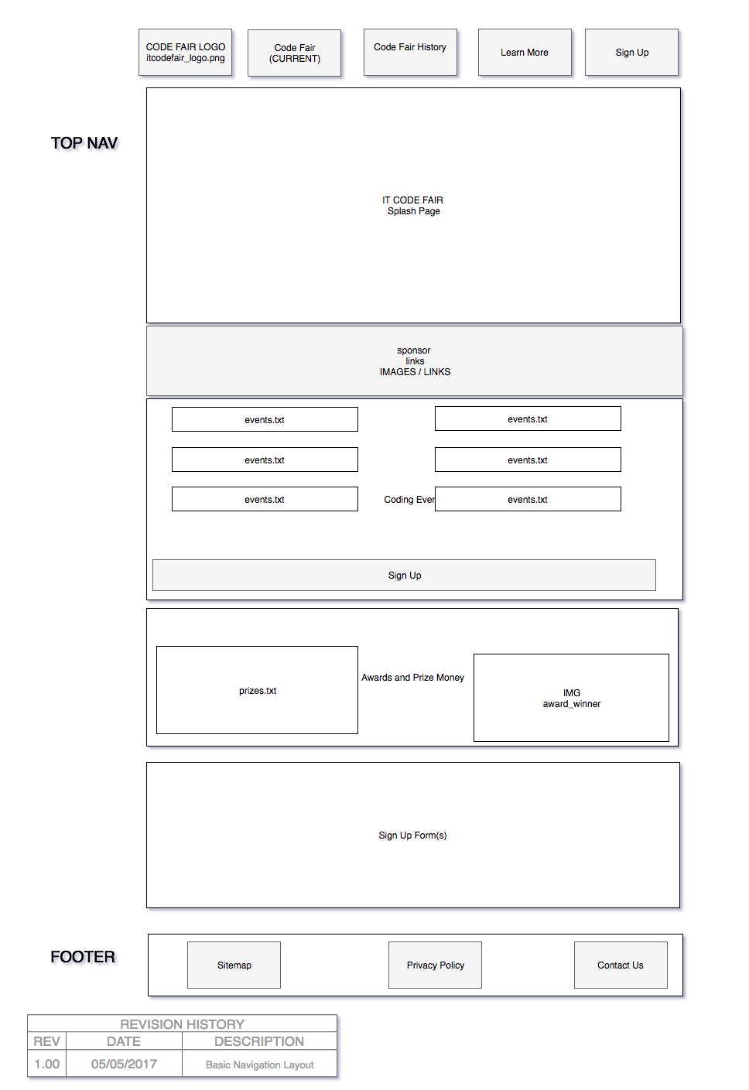Figure 3 – Paper Wireframe “index.html”

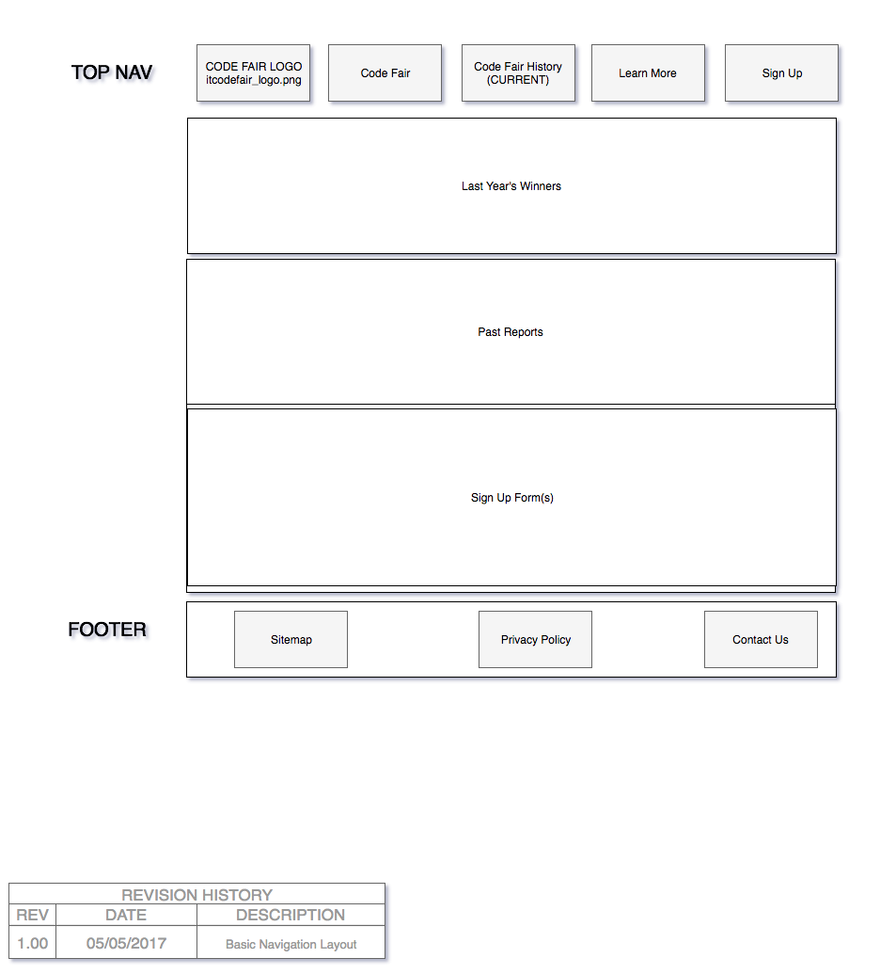

Figure 4 – Paper Wireframe “pastevents.html”

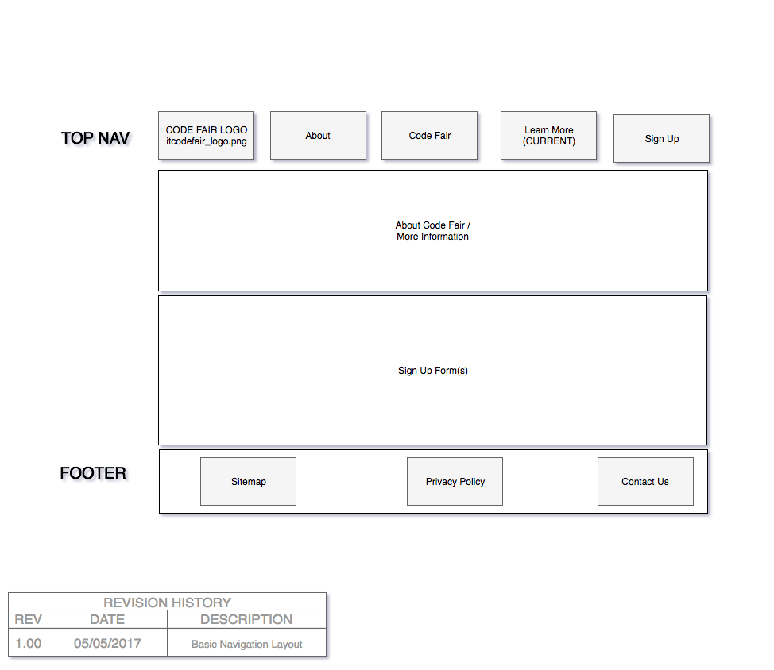Figure 5 – Paper Wireframe “learnmore.html”

Appendix 4 Usability testing

### Usability Test 1 – Directed Activity

Tester Name: Laura Harris

Tester Mobile: 0400659326

Tester Address: 13 Gregory Ave, Padbury, WA

| Scenario | Pathway(s) | Success  (Circle 1) | Notes/Observations |
| --- | --- | --- | --- |
| Example | n/a | 0  Not completed  1  Completed with difficulty or help  2  Easily completed | (Note why was the user successful or not successful, e.g., wrong pathways, confusing page layout, navigation issues, terminology) |
| Scenario 1 | Clicked on “Learn More” -> Scrolled up and down a bit -> Clicked on “Past Events” – Scrolled up and down a bit again -> Found “Contact Us” | 1  Completed with difficulty or help | The user went straight to the “Learn More” page, which does appear to make sense, however there isn’t a specific location for industry people to look for how to get involved information. |
| Scenario 2 | Clicked on “Learn More” -> Scrolled to “FAQ” -> Clicked on “Past Events” –> Clicked on “Code Fair 2017” –> Scrolled down, found “Industry Employer Speed Dating” -> Clicked on “Sign Up” | 1  Completed with difficulty or help | The user again went straight to “Learn More” and didn’t scroll down straight away. After this went to past events, but more out of just confirming it wasn’t there because that was the last link. Then with a hint clicked back on Code Fair 2017 (home page) and scrolled down to “WANT TO SHOW OFF YOUR CODING SKILLS?’ Confirming requirement. Clicked on Sign Up straight away. |

### Usability Test 2 – Directed Activity

Tester Name: Adam Collinson

Tester Mobile :0437 397 488

Tester Address: 4 Islington Street, Cranebrook NSW 2749

| Scenario | Pathway(s) | Success  (Circle 1) | Notes/Observations |
| --- | --- | --- | --- |
| Example | n/a | 0  Not completed  1  Completed with difficulty or help  2  Easily completed | (Note why was the user successful or not successful, e.g., wrong pathways, confusing page layout, navigation issues, terminology) |
| Scenario 1 | User clicked on the “Sign up” button-🡪scrolled up to the top of the page🡪clicked on Past Events🡪scrolled down to “Sign up Form”🡪found “Contact Us”🡪 | 1  Completed with difficulty or help | User was expecting to fill in a form, which they saw as being only relevant to the student / participants. The user then explained they were looking for an email address.  User suggested a link or section just for Industry Participation |
| Scenario 2 | User clicked across each nav menu item from left to right🡪clicked on Code Fair 2017🡪found event “Employer Speed Dating”🡪tried to click on the heading | 1  Completed with some difficulty or help | User stated they were browsing the nav menus “out of habit” and out of curiosity.  User found the “events” section of the site, but tried to click on the heading for more information. User suggested a link for more information on the Employer Speed dating event. |